Set up these circuits and compare the brightness of the each lamp with lamp A.
Use the code B = brighter, D = dimmer, or S = same brightness.
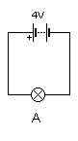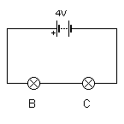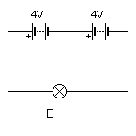
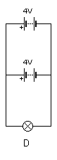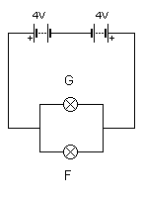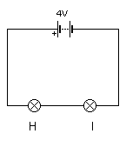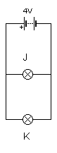
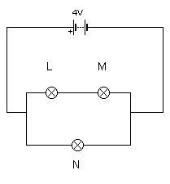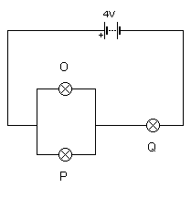
A = | B = | C = | D = | E = | F =
G = | H = | I = | J = | K = | L =
M = | N = | O = | P = | Q =

Set up these circuits and compare the brightness of the each lamp with lamp A.
Use the code B = brighter, D = dimmer, or S = same brightness.
A = | B = | C = | D = | E = | F =
G = | H = | I = | J = | K = | L =
M = | N = | O = | P = | Q =

